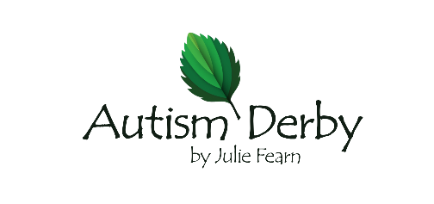

Autism Derby by Julie Fearn - GDPR Data Privacy Notice

Autism Derby by Julie Fearn take your privacy seriously. In this Privacy Policy we’ve provided relevant information on when and why we collect your personal information, how we use it, the limited conditions under which we may disclose it to others and how we keep it secure. Autism Derby by Julie Fearn is registered with the Information Commissioner’s Office (ICO) as a Data Controller.

Who we are?
Autism Derby by Julie Fearn was established by Julie Fearn, Independent Autism Advisor, in 2019. Julie is an Independent Autism Advisor with a degree in Autism. Julie has worked for the Local Authority for over 30 years, initially in a mainstream school with an enhanced resourced provision and for a local authority for a Specialist Teaching Service providing support for education schools and settings and parents and families in their home. Julie has worked in mainstream and specialist settings. She has a longstanding and updated continued professional development (CPD) specialising in approaches for children and young people with autism including PECS, TEACCH including visual systems, Intensive Interaction, Attention Autism, Social Stories and Comic Strip Conversations, and other autism specific approaches. Services include assessments, structured teaching, consultancy, training and support. The website provides information and resources for parents and schools.

What types of data do we collect?
When a client contacts us to provide specialist support, an assessment or training we collect a range of information to enable us to fulfil that service provision.
This might include:
• Personal identifiers and biographical information, for example date of birth
• Contact details – for example home address, email address and telephone number
• Sensitive personal data - for example, details of why an individual seeks an assessment, details of a disability or specific learning difficulty, details of support a client/learner may have had in the past, assessment data, and notes written during and after support or assessment sessions or after other contact with client/learner
• Dates of meetings held with a client/learner
• Family Details – for example details of other family members with whom a client/learner or
a client/learner’s school/college/workplace have given us consent to liaise

Why do we collect this information?
We collect this information to enable us to plan and provide structured teaching, assessments, specialist support, reports, or information and advice that the client has requested. It may also be that you have registered to attend or requested information about a training event. On request of a client, the client’s email address will be held on a generic mailing list for the sole purpose of a generic mail shot of generic information to be shared with Autism Derby clients. The email will be removed at the request of the client at any point.

How is this information stored?
All information is stored either on secure iCloud storage which is accessed via a secure laptop, or in a secure filing cabinet. Sensitive documents such as reports are also individually password protected.

Who might we share this information with?
Any data obtained by us will not be shared with any other organisation or individual without specific consent by you. In order to share information with another agency such as a school, health professional or another assessor, a specific written request will be made. The written request will state the name of the person/organisation that the information is to be shared with, what information will be shared and the reasons for sharing the information. This specific consent covers written information shared electronically or on paper and verbal information shared in conversations.

Access to your personal information
You are entitled to view, amend, or delete the personal information that we hold. If you wish to do this, please email your request to Julie Fearn julie@autismderby.co.uk Please Note: Requests from clients to delete data relating to an individual will be considered on a case by case basis but we may be unable to remove all records and support notes for legal reasons.

Changes to this Privacy Notice
This Privacy Notice was reviewed in January 2023 and will be reveiwed in 1 year
Review 1 - January 2023 – no changes made

